Start document PiJukebox

Before starting to build the project, make sure all versions are equal to the ones used.

**IntelliJ**

IntelliJ IDEA 2018.3.3 (Ultimate edition)

Build: #IU-183.5153.38 (January 9, 2019)

**Polymer**

Polymer 3.1.0

**Polymer-CLI**

Polymer 1.9.1 or below 2.0.0

**Java JRE**

Java JRE 1.8.0_152-release

**XAMPP**

XAMPP Control Panel version 3.2.2

**MySQL**

Version: 10.1.8-MariaDB

**NodeJS**

Download latest version from ‘**Current**‘:

<https://nodejs.org/en/download/current/>

**NPM – Polymer**

Version: 6.8.0

npm install -g polymer-cli

How to build the back-end

Open up the IntelliJ IDEA, go to:



Then browse to the location where the project is saved:

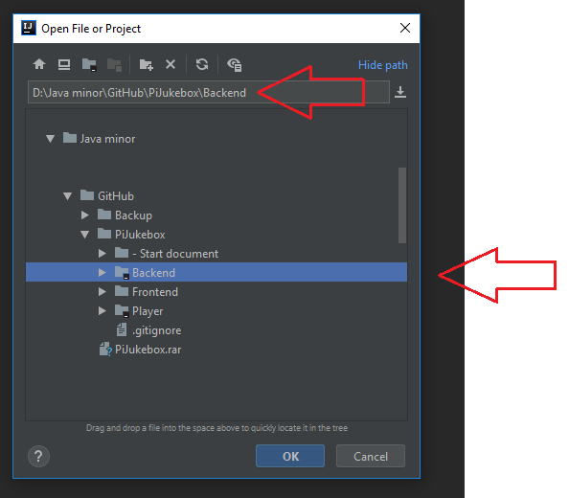

The moment the project is loaded in it’ll look similar if not equal to the next image:

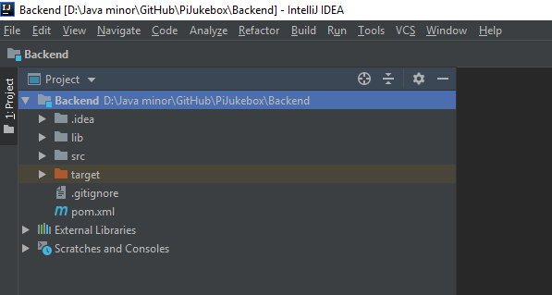

If the project cannot be run at this moment, thus it needs to be configured.

Go to the right top corner and click on:

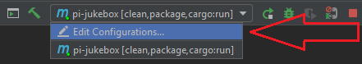

Then click on the + sign in the window and look for Maven.

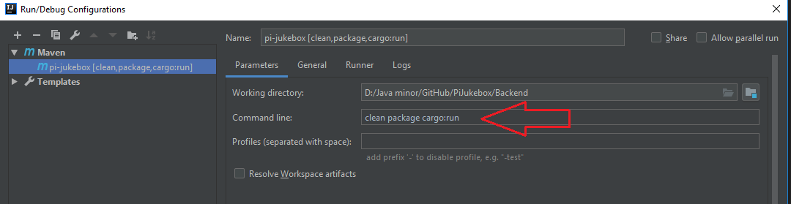

When maven is added make sure the Command line states: clean package cargo:run

This way the IDEA knows it’s talking to an Maven Project and knows how to handle the POM file in the PiJukebox project. ***If it asks to auto-import Maven related dependencies, click on it***, this way it’ll download all the dependencies we used stated in the POM file. If the project is asking to use a valid SDK, use Java JRE 1.8.0_152-release

Now the project can be run by pressing the Play button: (Next image as reference)

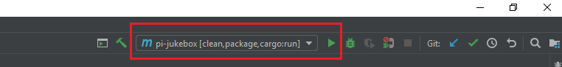

Now the project will start building, compiling and running:

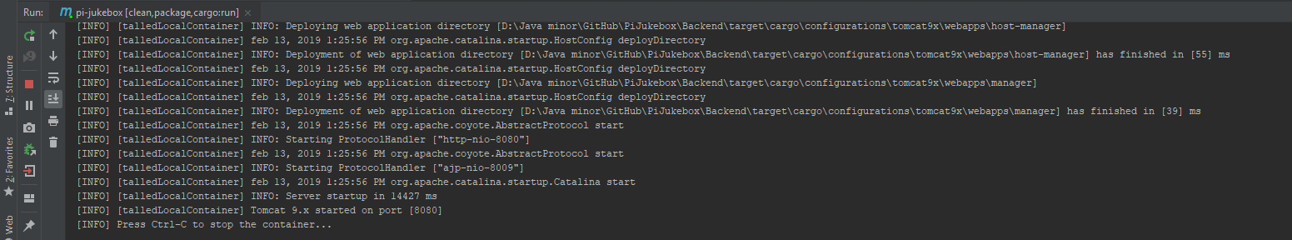

The moment it’s showing (Press Ctrl-C to stop the container…) it’s done building and running.

There is a high probability small things aren’t configured correctly, for example the Database and music path.

To change the Database to the one active now, open the project file “DatabaseConfig” through IntelliJ and check if the USER_NAME and PASSWORD are correctly set. (Check next image for reference)



The music path also has to be edited to the correct location. Open up the PlayerController and change the path to the folder which contains the music. **Make sure there are two \\ at the end of the path** (Check next image for reference)

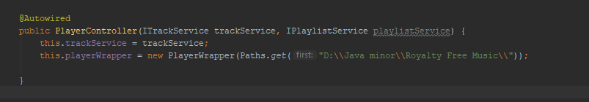

Due to the high volume needed for the songs the team decided to use Google Drive to separate it from the Github branch. Hence the songs can be downloaded through the following link:

<https://drive.google.com/drive/folders/1sdjMxZVXQtiJAYcve6CkkSFFfXI_plSi?usp=sharing>

How to build the front-end

Before you can work properly with the front-end it needs to be setup and configured.

Download the latest version of Node.js from the ‘current’ branch.

To make sure you have it installed, open CMD and type: “node --version”.

Also make sure you have NPM installed with the command: “npm install -g polymer-cli”

To see if you have the latest version installed, open CMD again and type: “npm --version”.

If you see the versions showing up from both of them you’re good to go on building the front-end.

Navigate to the place you have the project saved and go to the folder called “frontend”.

When you are in the folder “frontend” open CMD and use the command: “npm install”

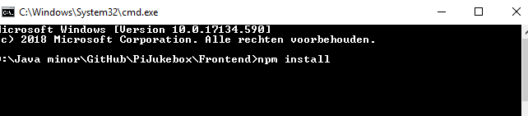

This is fetching all the latest versions and when it’s done, it should look similar:

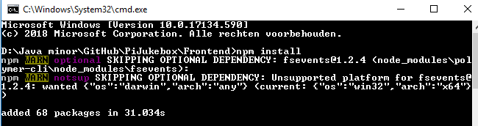

When that’s done, you can use the command in CMD: “Polymer serve” , it will look like this:

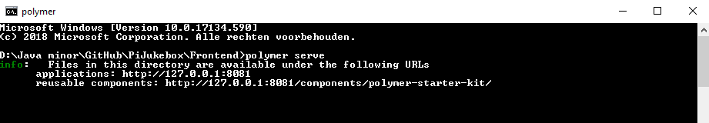

Open your browser now, and navigate to: <http://127.0.0.1:8081> (Default polymer)

